Module 2 – MERN Stack Assignment– HTML
HTML Basics
Theory Assignment

Question 1: Define HTML. What is the purpose of HTML in web development?
Ans:- HTML provides the basic structure of a website by defining elements like headings, paragraphs, images, links, forms, and layouts, allowing browsers to display content correctly on the web.

• Question 2: Explain the basic structure of an HTML document. Identify the mandatory tags and their purposes.
Ans:- Mandatory tags and their purposes:
- <!DOCTYPE html> – Declares the document type and HTML version.
- <html> – Root element that wraps the entire HTML document.
- <head> – Contains metadata like title, charset, and links to CSS.
- <title> – Sets the page title shown on the browser tab.
- <body> – Contains all visible content of the web page (text, images, links, etc.).

• Question 3: What is the difference between block-level elements and inline elements in HTML? Provide examples of each.
Ans- Difference between Block-level and Inline elements in HTML:
Block-level elements:
- Start on a new line and take up the full width available.
- Can contain other block and inline elements.
- Examples: <div>, <p>, <h1> to <h6>, <section>
Inline elements:
- Do not start on a new line and take only the required width.
- Usually used inside block elements.
- Examples: <span>, <a>, <img>, <strong>

• Question 4: Discuss the role of semantic HTML. Why is it important for accessibility and SEO? Provide examples of semantic elements.
Ans:- Role of Semantic HTML:
Semantic HTML uses meaningful tags that clearly describe the purpose of the content they contain. It helps browsers, search engines, and assistive technologies understand the structure of a web page.
Importance for Accessibility:
- Screen readers can better interpret content for visually impaired users.
- Improves keyboard navigation and content clarity.
- Clearly defines landmarks (header, nav, main, footer).
Importance for SEO:
- Search engines understand page structure and content relevance.
- Helps improve search rankings and rich search results.
- Makes content more indexable and meaningful.
Examples of semantic elements:
- <header> – Page or section header
- <nav> – Navigation links
- <main> – Main content
- <section> – Thematic grouping of content
- <article> – Independent content
- <aside> – Side content
- <footer> – Page or section footer
========================================================
HTML Forms
Theory Assignment
• Question 1: What are HTML forms used for? Describe the purpose of the input, text area, select, and button elements.
Ans:- Form Elements
- <input> – Used to take user input such as text, email, password, number, checkbox, radio, file, etc.
- <textarea> – Used to enter multi-line text, like comments or feedback.
- <select> – Creates a dropdown list for selecting one or more options.
- <button> – Used to submit, reset, or trigger an action in the form.

• Question 2: Explain the difference between the GET and POST methods in form submission. When should each be used?
Ans:- GET Method
- Sends form data in the URL.
- Data is visible and has length limits.
- Can be bookmarked.
- Less secure.
Use GET:
- Fetching data
- Search forms
- Non-sensitive data

POST Method
- Sends form data in the request body.
- Data is not visible in the URL.
- No size limit (practically).
- More secure than GET.
Use POST:
- Sending sensitive data (passwords, personal info)
- Uploading files
- Submitting large data

• Question 3: What is the purpose of the label element in a form, and how does it improve accessibility?
Ans:- Purpose of <label> Element:
- The <label> tag defines a text label for a form control (input, text area, select).
========================================================
HTML Tables
Theory Assignment
Question 1: Explain the structure of an HTML table and the purpose of each of the following elements: <table>,<tr>,<th>,<td>and<thead>.
Ans:- HTML Table Structure & Elements
- <table> – Defines the entire table.
- <tr> (Table Row) – Creates a row in the table.
- <th> (Table Header) – Defines header cells; text is bold and centered by default.
- <td> (Table Data) – Defines data cells that hold table content.
- <thead> – Groups the header rows of a table for better structure and accessibility.

Question 2: What is the difference between cols panand rows Panin tables? Provide examples.
Ans:-
- colspan
- Used to merge multiple columns into one cell.
- Expands a cell horizontally.
- rowspan
- Used to merge multiple rows into one cell.
- Expands a cell vertically.

• Question 3: Why should tables be used sparingly for layout purposes? What is a better alternative?
Ans:-
- They are meant for tabular data, not page design.
- Make code harder to maintain.
- Reduce accessibility for screen readers.
- Are not responsive on different screen sizes.
- Negatively affect SEO.
Better Alternative:
- Use CSS layout techniques such as:
- Flexbox
- CSS Grid

Lab Assignment
HTML Basics
Task:- Create a simple HTML webpage that includes: • A header (), footer (), main section (), and aside section (). • A paragraph with some basic text. • A list (both ordered and unordered). • A link that opens in a new tab.
Output:-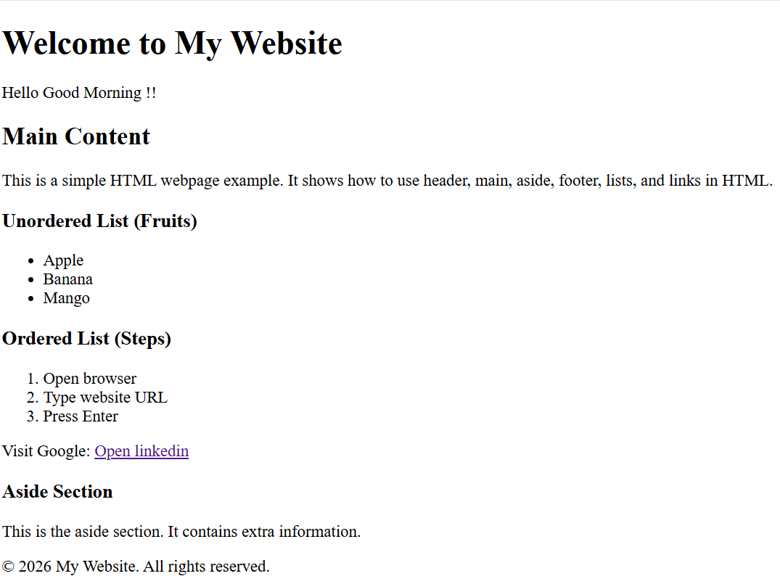

HTML Forms
Task: Create a contact form with the following fields: • Full name (text input) • Email (email input) • Phone number (tel input) • Subject (dropdown menu) • Message (textarea) • Submit button Additional Requirements: • Use appropriate form validation using required, minlength, maxlength, and pattern. • Link form labels with their corresponding inputs using the forattribute
Output:- 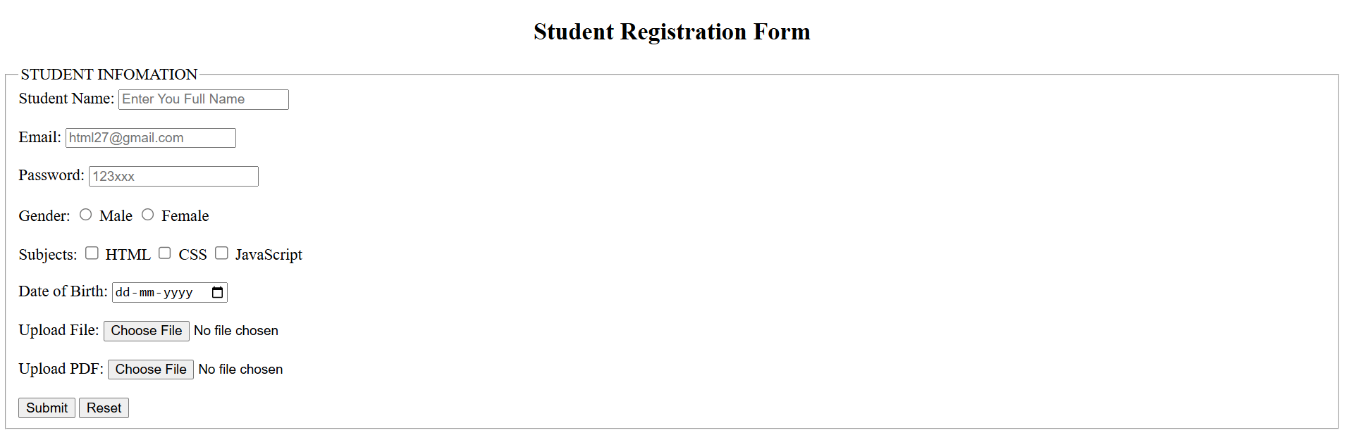

HTML Tables
Task:- Create a product catalog table that includes the following columns: • Product Name • Product Image (use placeholder image URLs) • Price • Description • Availability (in stock, out ofstock) Additional Requirements: • Use theadfor the table header. • Add a border and some basic styling using inline CSS. • Use colspanor rowspanto merge cells where applicable.
Output:- 